Phase 7: Project Documentation Phase
Prepare the complete technical documentation for Pocket Smart AI.
Write the project title, abstract, and introduction.
Explain the background and motivation of the project.
Clearly define the problem statement.
Describe the proposed solution.
Define the objectives of Pocket Smart AI.
Explain the scope of the project.
Document the functional requirements.
Document the non-functional requirements.
Explain the technologies used in the project.
Document the software and hardware requirements.
Explain the overall system architecture.
Include the architecture diagram and explain each component.
Document the frontend architecture.
Document the Fast API backend architecture.
Explain the Gemini AI integration.
Explain the recommendation-generation process.
Document the Home Interior Planner.
Document the Party Budget Planner.
Document the Jewelry Budget Planner.
Explain the authentication and session-management system.
Document the important API endpoints.
Explain the project folder and file structure.
Include screenshots of the major application pages.
Document the following pages:
Home Page
Register Page
Login Page
User Dashboard
Home Interior Planner
Home Recommendations
Party Planner
Party Recommendations
Jewelry Planner
Jewelry Recommendations
Recommendation History
Document the testing methodology.
Prepare test cases and expected results.
Document actual testing results.
Explain errors identified during testing and the corrections made.
Document the limitations of the current system.
Describe possible future enhancements.
Prepare the project conclusion.
Add references and supporting resources.
Review the complete report for grammar, formatting, consistency, and technical accuracy.
Organize headings, tables, figures, screenshots, and page numbers properly.
Prepare t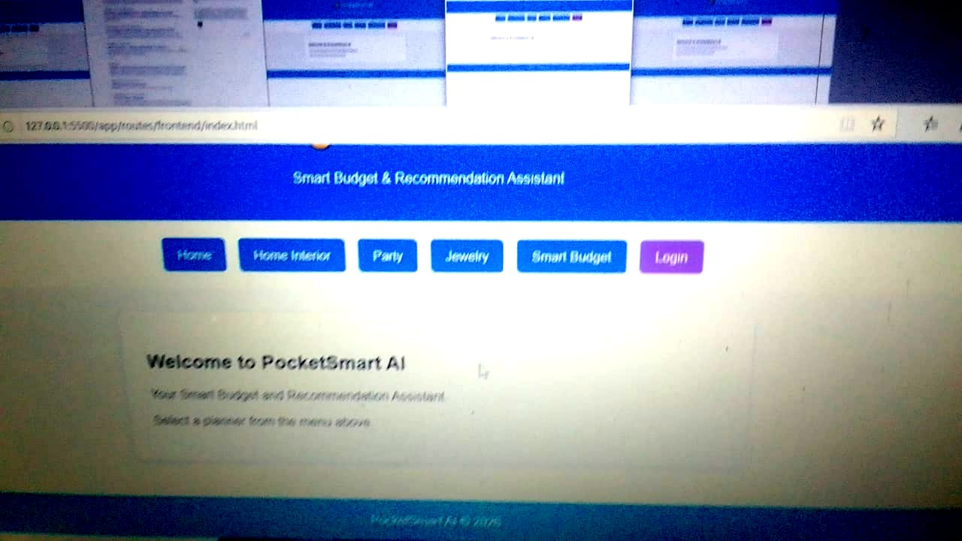he final project report for submission.

